

A Project Report on
<Title>

Submitted in partial fulfilment for award of degree of

<Program Name>
In Cybersecurity

Submitted by

<Name of the Student>
<SRN>

Under the Guidance of
<Name of the Guide>
<Designation>

REVA Academy for Corporate Excellence
REVA University
Rukmini Knowledge Park, Kattigenahalli,
Yelahanka, Bangalore – 560064

<Month, 2025>

Candidate’s Declaration

I, <Student Name>, hereby declare that I have completed the project work towards <Post Graduate Diploma/Master of Technology/Master of Science> in Cybersecurity at REVA University on the topic entitled <Title of Project> under the supervision of <Name of Guide and designation>. This report embodies the original work done by me in partial fulfilment of the requirements for the award of the degree for the academic year <Year>.

Place: Bengaluru Name of the Student:
Date: Signature of Student

Acknowledgment of Project Ownership and Usage Rights

I, _________________________, a student enrolled in the ________________Program and ________Year at RACE, hereby acknowledge that any project, including but not limited to software, hardware, research, or other intellectual property created by me during my academic tenure at RACE, is the property of RACE, REVA University.

I understand and agree that RACE has the exclusive rights to use, reproduce, modify, or distribute the aforementioned projects for academic, research, and further development purposes. This includes the right to monetize, commercialize, or otherwise exploit the projects as deemed fit by RACE.

I acknowledge that I have no objection to RACE, REVA University, using, reproducing, or further developing the projects for the benefit of the institution and its academic community. I further affirm that any commercial or research activities related to the projects conducted by RACE shall not require additional consent or approval from me.

This acknowledgment is made willingly and without any reservations. I am grateful for the education and opportunities provided by RACE, and I recognize the importance of contributing to the academic and research goals of the institution.

Place: Bengaluru Name of the Student:
Date: Signature of Student

Certificate

This is to certify that the project work entitled <Title of the Report> has been carried out by <Student’s Name> with <SRN>, who is a bonafide student of REVA University, is submitting the <first/second-year> project report in fulfilment for the award of <Post Graduate Diploma/Master of Technology/Master of Science> in Cybersecurity during the academic year <Year>. The project report has been tested for plagiarism and has passed the plagiarism test with a similarity score of less than 15%. The project report has been approved as it satisfies the academic requirements in respect of the project work prescribed for the said degree.

Signature of the Guide Signature of the Director
<Name of the Guide> <Name of the Director>
Guide Director

External Viva
Names of the Examiners
- <Name> <Designation> <Signature>
- <Name> <Designation> <Signature>

Place: Bengaluru
Date:

Acknowledgment

Please acknowledge the role of your mentors, trainers, classmates, program office members, family and friends who have directly and indirectly supported you in this work.

Please acknowledge the support provided by the Hon’ble Chancellor, Dr. P Shayma Raju, Hon’ble Vice Chancellor, Dr. Sanjay Chitnis, and Registrar, Dr. M. Dhanamjaya, as a standard protocol.

Place: Bengaluru
Date:

Similarity Index Report

This is to certify that this project report titled <Title of the project> was scanned for similarity detection. The process and outcome are given below. The plagiarism report is attached in the appendix.

Software Used: Turnitin
Date of Report Generation:
Similarity Index in %:
Total word count:
Name of the Guide:

Place: Bengaluru Name of the Student:
Date: Signature of Student

Verified by:

Signature
Dr. Shinu Abhi,
Director, Corporate Training

List of Abbreviations

Sl. No | Abbreviation | Long Form
1 | WSNs | Wireless Sensor Networks
2 | CPNS | Cyber Physical Network Systems

List of Figures

No. | Name | Page No.
Fig.1.1 | Wireless Sensor Networks | 12
Fig.1.2 | Cyber Physical Network Systems | 17

List of Tables

No. | Name | Page No.
Table 1.1 | Wireless Sensor Networks | 9
Table 2.1 | Cyber Physical Network Systems | 10

Abstract
(Not to exceed 1 page)
The Abstract is an important part of the report. A succinct summary of the longer report allows the reader to quickly become familiar with the work described in the report without having to read it all. It briefly advises the reader of the problem, and background information includes the strategic importance of the problem, a concise analysis of the problem, and the primary conclusions and recommendations. Search-friendly keywords to be mentioned.

The abstract should clearly describe the background and introduction, problem statement, objective, methodology used, results, and analysis.

*CRITICAL: Do Not Use Symbols, Special Characters, Footnotes, or Math in Paper titles in the abstract.

Keywords:
Cybersecurity, Threat Detection, Network Security, Vulnerability Assessment, Risk Management, Intrusion Detection, Data Protection, Incident Response

Table of Contents
Candidate’s Declaration 2
Acknowledgment of Project Ownership and Usage Rights 3
Certificate 4
Acknowledgment 5
Similarity Index Report 6
List of Abbreviations 7
List of Figures 7
List of Tables 7
Abstract 8
Chapter 1: Introduction 10
Chapter 2: Literature Review 12
Chapter 3: Problem Statement 13
Chapter 4: Objectives of the Study 14
Chapter 5: Project Methodology 15
Chapter 6: Resource Requirement Specification 16
Chapter 7: Software Design 17
Chapter 8: Implementation 18
Chapter 9: Testing and validation 19
Chapter 10: Analysis and Results 20
Chapter 11: Conclusions and Future Scope 21
Bibliography 22
Appendix 23
Plagiarism Report 24
Paper Publications in a Journal/Conference Presented/White Paper 27
Certificate for the Conference Presentation 36
Github Link 37

Chapter 1: Introduction

(2-3 Pages)
Introduction presents the specific problem under study. It includes general Introduction to the area of your work, current technical advancement in the area, the need of such study, scope of the study etc. State how this study will help organizations/ community. You can use figures, tables, and references in the introduction.

1.1 Topic Heading
You can write the statements here related to your major topic.
1.1.1 Sub-Topic Heading
You can write the statements here related to the sub-topic within the major topic.
1.1.2 Equations
Punctuate equations with commas or periods when they are part of a sentence, as in:
a  b    
Note that the equation is centered using a center tab stop. Be sure that the symbols in your equation have been defined before or immediately following the equation. Use Eq. (1.1) to refer in text.
1.2 Figures and Tables
This section describes how to place and define figures and tables.
1.2.1 Figures
Figures must be clearly visible and must be aligned in centre. Place figures and tables at the top and bottom of columns. Avoid placing them in the middle of columns. Figure captions should be below the figures. Insert figures and tables after they are cited in the text. Use the abbreviation “Fig. 1”, even at the beginning of a sentence. Figure Labels: Use 12-point Times New Roman for Figure labels.
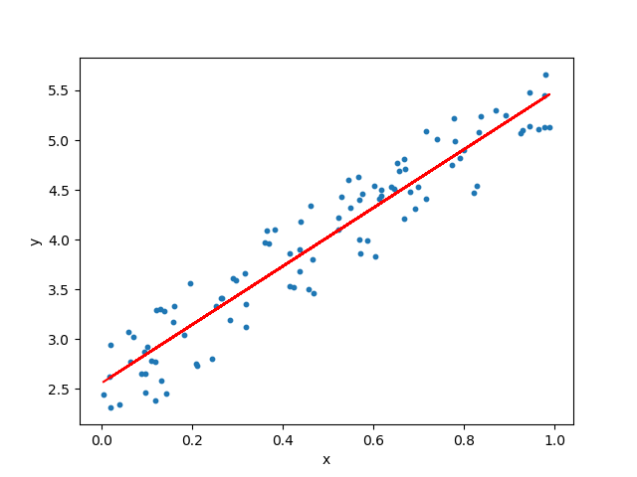
Fig 1.1: Simple Linear Regression

1.2.2 Tables
Tables must be aligned in centre. Table heads should appear above the tables. Use 12-point Times New Roman for Table labels.
Table 1.1: Table Name
Table Head | Table Column Head
Table Head | Table column subhead | Subhead | Subhead
copy | More table copyª

Chapter 2: Literature Review

(2-3 pages)
Review of background theory and existing literature: A Minimum of 15/20 references from renowned journals/technical reports/websites that must support the problem formulation. A literature review constitutes an essential chapter of a thesis or dissertation, or may be a self-contained review of writings on a subject. In either case, its purpose is to:

- Place each work in the context of its contribution to the understanding of the subject under review
- Describe the relationship of each work to the others under consideration
- Identify new ways to interpret, and shed light on any gaps in, previous research
- Resolve conflicts amongst seemingly contradictory previous studies
- Identify areas of prior scholarship to prevent duplication of effort
- Point the way forward for further research
- Place one's original work in the context of existing literature

Any references taken from websites/journal article/industry whitepapers need to be referenced in text and in the end of the report as Bibliography.

Sample Only:
IEEE 802.11 [1] is a set of Wireless LAN standards developed by working group 11 of the IEEE 802 committee. Successful businesses benefit from these standards both by actively participating in the standardization process and by using standards as strategic market instruments [2].

Use Mendeley for Referencing: Journal articles/websites as per the APA/IEEE protocols which you have referred to while writing this abstract. You must use Mendeley to manage references.
Avoid or keep a minimal referencing from Wikipedia and websites. Majority of the references must be from peer reviewed journals

Chapter 3: Problem Statement

(1 page)
Expand on the Title of the project here. The problem statement (of your project) must be clearly defined as a statement.

A problem statement is an explanation in research that describes the issue that needs your study. What problem is the research attempting to address? Having a Problem Statement allows the reader to quickly understand the purpose and intent of the research.

Additionally, you may add a paragraph on the internal and external environment where the problem is found, i.e., organization, community, etc. It shall describe groups or organizations affected by the problem (stakeholders), how they are involved, where they are located, and why they have an interest in the problem. A brief history of the problem can be included with the extent and longevity of the problem, how it has changed over time, and significant events which have contributed or influenced the problem. This discussion shall also address ramifications of the problem (strategic significance), its symptoms, and why the problem is worthy of study.

Chapter 4: Objectives of the Study
(1 page)
This section shall clearly describe the purpose of the capstone project and the benefit to be gained, i.e. goals. Goals should be stated in terms of what the student is attempting to discover by conducting the research and clearly describe why this is of strategic/operational importance to the organization/community. This section may require revision as the literature review progresses and understanding of the problem is refined.

The objectives must be clearly numbered and must have 3-4 objectives. Each objective must start with a verb.

Chapter 5: Project Methodology
(2 pages)
The Methodology section contains a description of the process that will be used to conduct the project. The tools used in the project must be specifically identified and their use must be related to solving the problem that is the focus of the capstone project
Problems faced when implementing the methodology should be discussed in the Capstone Report as well as how they were resolved. This section is written in two steps. This section addresses potential problems and how they will be resolved. If the research methodology/design was changed during the conduct of the project, the changes, and the reasons for them should be addressed in this section. The project methodology should be designed to allow conclusions to be drawn about the stated problem.

Chapter 6: Resource Requirement Specification
(2-3 pages)
This section outlines the key resources required for the successful execution of the project. It includes hardware, software, data, and human resources necessary for development, testing, and deployment. Clearly specifying these requirements ensures that the project is feasible, efficient, scalable and reproducible.
Section 1: Brief Summary
- Provide a brief paragraph introducing the resource requirements:
- Summarise the project’s technical scope and why specific resources are essential.
Example:
“The proposed project on AI-based Fraud Detection requires computational, software, and data resources to design, train, and evaluate predictive models. The resources listed below ensure reproducibility, scalability, and secure handling of data.”
Section 2: Hardware Requirements: List the computing infrastructure, devices, and any hardware-specific needs.
Category | Specification / Description | Purpose
Processor | Intel i7 / AMD Ryzen 7 or higher | Model training and data processing
RAM | Minimum 16 GB | Smooth execution of ML workloads
GPU | NVIDIA RTX 3060 / Google Colab Pro / AWS GPU instance | Deep learning model training
Storage | 250 GB SSD or higher | Dataset and model storage
Peripherals | Webcam, microphone (if required) | Data collection / testing

Section 3: Software Requirements: Mention all programming tools, environments, libraries, and operating systems used.
Type | Tool / Software | Version | Purpose / Justification
Operating System | Windows 11 / Ubuntu 22.04 | — | Development environment
Programming Language | Python 3.10 | — | Primary language for ML development
IDE | VS Code / Jupyter Notebook | — | Coding and documentation
Libraries | Pandas, NumPy, TensorFlow, Scikit-learn | Latest stable | Data handling and ML model building
Database | MySQL / MongoDB | — | Data storage
Cloud Platform | AWS / Azure / Google Cloud | — | Deployment and scalability
Section 4. Data Requirements: Describe the nature, source, and volume of data required.
- Type: Structured / Unstructured / Image / Text / Audio
- Source: Open datasets (Kaggle, UCI), internal databases, API data, synthetic generation
- Size: Approx. number of records or file size
- Data Privacy Measures: Mention anonymization, encryption, or compliance aspects if applicable.
Example:
“The project uses the CIC-IDS2017 dataset (~3 GB, CSV format) containing labeled network traffic data for intrusion detection. Data is stored securely in encrypted local folders and used only for academic purposes.”
Section 5: Other Resources (if applicable) Include:
- APIs / Licenses: e.g., Google Vision API, OpenAI API, Tableau license
- Access Requirements: GitHub repo, remote lab servers, VPN access
- External Dependencies: Company datasets, client infrastructure
Section 5: Concluding para with resource sponsor if any, challenges faced etc.

Chapter 7: Software Design
(4-5 pages)
Software design – high level (class diagram (for OOD)/architectural diagram (for structured approach)) and low level (state diagram, sequence diagram (for OOD))/flowchart (for structured approach).
You may use MS-Visio, or Draw.io or any such tools to draw professional-looking diagrams.
Guidelines:
- Use diagrams effectively — one per major section (architecture, sequence, data).
- Keep text-to-diagram balance (2–3 paragraphs of explanation per diagram).
- Maintain numbered figure captions and references in text.
- Use consistent naming between design diagrams and code modules.
- Avoid tool screenshots or ensure that the diagrams are well-cropped — use clean UML or draw.io diagrams.

Chapter 8: Implementation
(4-5 pages)
Implementation –Code/ scripts description for every key module to be shared.
Guidelines: Each objective stated in the Project Objective Chapter (Chapter 4) must be addressed here, showing how it was implemented in code. Write one subsection per objective, include pseudocode or snippets, and describe how the implementation fulfils that goal with a clear description of each screenshot.

Chapter 9: Testing and validation
(3-4 pages)
Design test cases for each functional requirement mentioned in previous chapter. Execute those on the implemented code. Results must be presented in one of the form mentioned below to justify the objectives stated, through relevant discussions and propose recommendations with substantiations.
- Text,
- Tables
- Illustrations-graphs, figures/screenshots
The contents of the tables should not be repeated in the text. Instead, a reference to the table number must be given.
Validation: Check whether Theoretical solutions to your problem is available with you or in any references Experimental results are available with you or with in some reference material. Verify /validate your results with the available results. If you are not verifying or validating your results, your results will be questioned; you should be in a position to defend your results, in such cases bench marking is necessary.
To benchmark, choose a standard problem in the area for which theoretical or experimental solutions are available, solve the problem using the method you have chosen for your project and compare your results. You need to provide explanations for the trends in your graphs and tables. The explanation should be based on theoretical background.

Chapter 10: Analysis and Results
(2-3 pages)
The result of project and analysis are presented in this section. This section includes the outcome of the methodology, i.e., the numerical or descriptive work that was performed. For example, if a SWOT analysis is performed, the results are included in this section. Likewise, if a technical analysis is performed, the computational results are included in this section.

Chapter 11: Conclusions and Future Scope
(2-3 pages)
This is the last section of the text in which conclusions or inferences drawn on the basis of the results of study are described. The conclusions should be linked with the objectives of the study. If possible to express your concluding remarks based on certain numbers, please do so. If you have developed correlations, give such correlations. Recommendations for further research may be included when appropriate. It is important to be careful that the conclusions should not go beyond data and should be based on the study results.

Bibliography
  - J. Zhao, G. Ji, Y. Tian, Y. Chen, and Z. Wang, “Environmental vulnerability assessment for mainland China based on entropy method,” Ecological Indicators, vol. 91, pp. 410–422, 2018.
  - G. R. Hiertz, D. Denteneer, L. Stibor, Y. Zang, X. P. Costa, and B. Walke, “The IEEE 802.11 universe,” IEEE Communications Magazine, vol. 48, no. 1, pp. 62–70, Jan. 2010.

Appendix

Plagiarism Report
Plagiarism Report with below 15% Similarly index to be attached in the annexure. The title page and last pages with the similarity index report are attached.


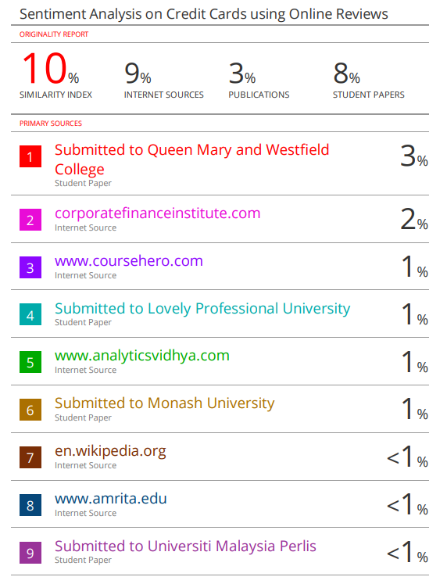


Paper Publications in a Journal/Conference Presented/White Paper
- Publication in a Journal/Conference Presented/White Paper – Full paper extracted from the journal / full conference paper and the certificate must be attached.
  - Those who have published: (Attach full paper)
[All authors Name in order], “[Article Title].” [Journal Name/Conference Name], [Volume Number], [Issue Number], [Year], [Pages], DOI.
  - For those who have not published yet may add submission information: (Attach full paper)
[All authors Name in order], “[Article Title].” [Journal Name/Conference Name], [Date of submission]
Eg: Madhukeshwar R K, Ratnakar Pandey, Shinu Abhi, “A Recommender System for Indian Credit Cards using Text Analytics.” NeuroQuantology, Volume 20, Issue8, 2022, Page 9021-9028, doi:10.14704/nq.2022.20.8.NQ44922
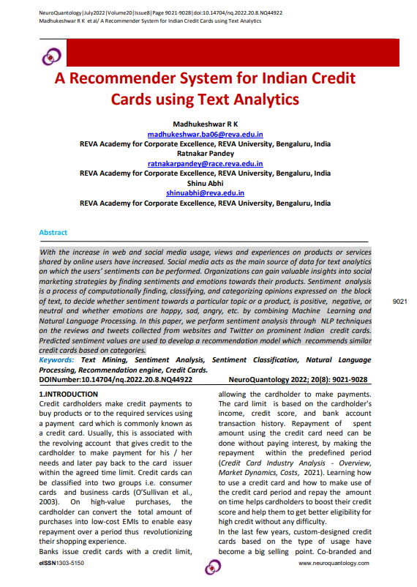
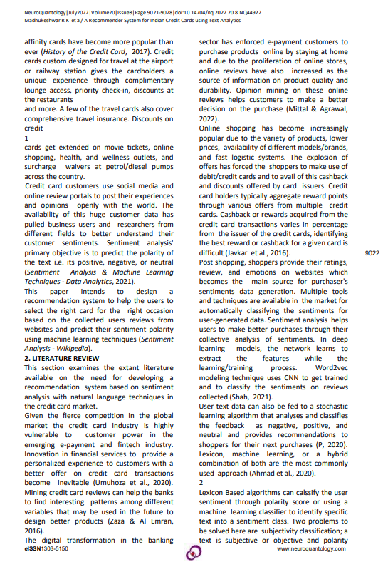
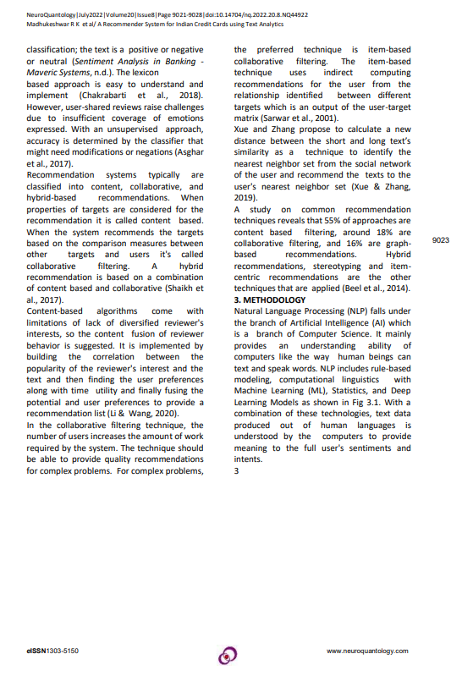

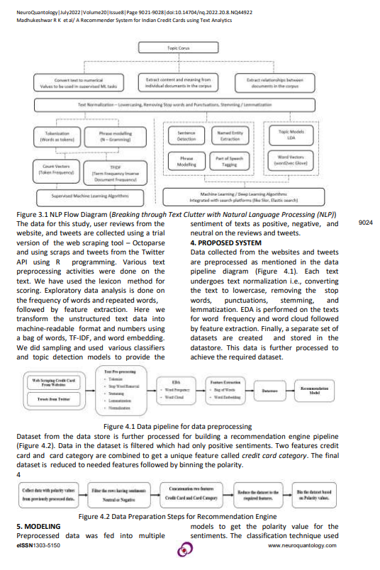
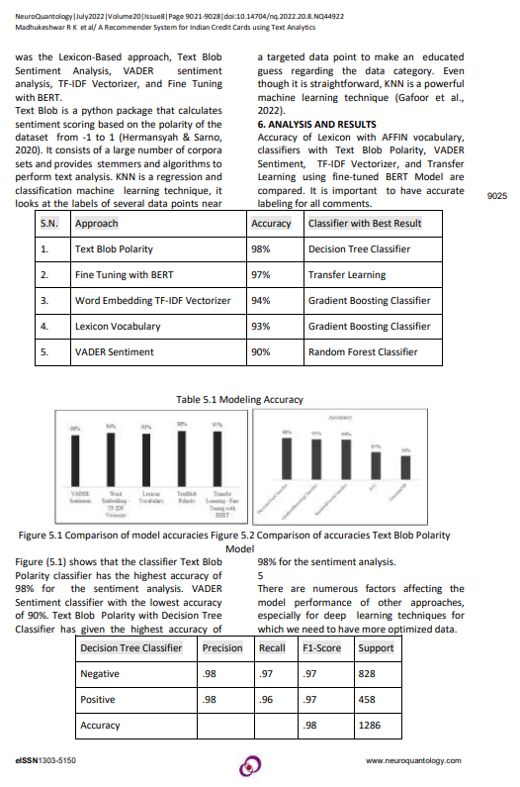
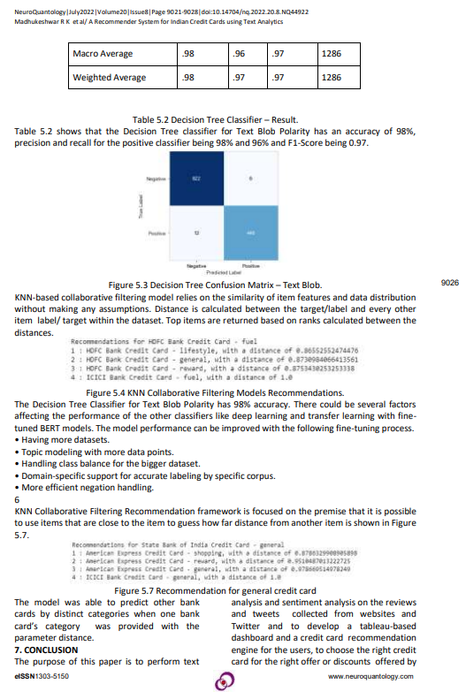
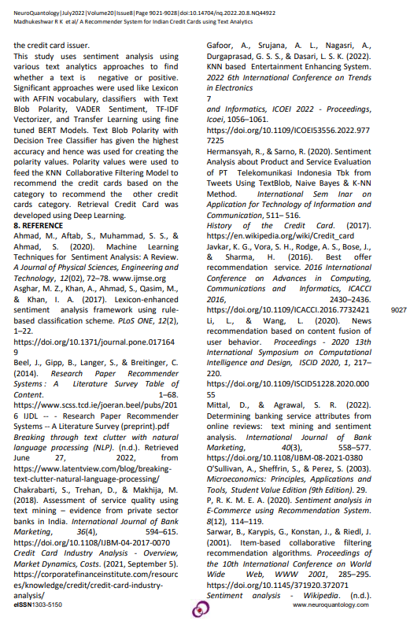
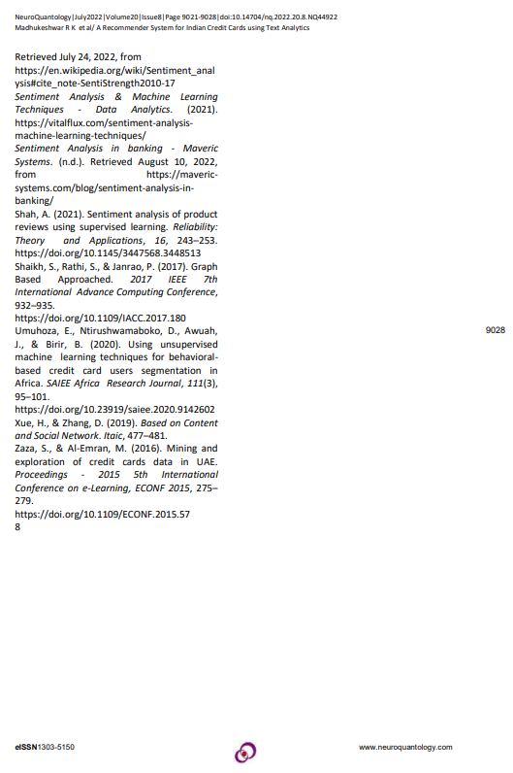

Certificate for the Conference Presentation



Github Link

https://github.com/kyasanur/Sentiment-Analysis-on-Credit-Cards-using-Online-Reviews

Additional Instructions (To be removed while submitting)
Formatting for Printing:
- The printing of your capstone project must be done with a RACE-approved printer only. Details will be shared.
- Cover page shall be in White hardbound (for both 1st and 2nd year projects) as per the template shared.
- The report shall be printed on an A4 size Executive Bond sheet.
- The font used shall be Times New Roman, and the font size shall be 12. For the Heading, use Times New Roman 14 in Bold and for the subheading, use Times New Roman 12 in Bold.
- The top, bottom, left and right margins shall be 1” each.
- The line spacing shall be fixed at 1.5 lines.
- Table line spacing shall be single line spacing.
- Page numbers shall be placed at the bottom right position.
- Chapters shall be numbered 1, 2, 3, etc. The tables and charts shall be in the format of 1.1, 1.2, etc. i.e., 1.1 indicate that it is the first table in Chapter 1; 2.1 Indicates the first table in Chapter 2. Similarly, chart no. 1.1 indicates the first chart in Chapter 1.
- The project report shall be a minimum of 40 pages and shall not exceed 75 pages for second-year projects and a minimum of 30 pages, and a maximum of 50 pages for first-year projects.
- You must submit three hard copies duly signed by the mentor and guide (scanned signature will be sufficient) and the Director along with a soft copy in pdf format. (Two copies to submit to the university and one is your copy).
- Title of the study, objectives, analysis, findings, and suggestions must tally.
- Each chapter must start on a fresh page.
Mandatory Inclusions
- Plagiarism Report with below 15% Similarly index to be attached in the annexure. The title page and last pages with the similarity index report are attached.
- Publication in a Journal/Conference Presented/White Paper – Full paper extracted from the journal / full conference paper and the certificate must be attached.
  - Those who have published: (Attach full paper)
[Authors Name], “[Article Title].” [Journal Name/Conference Name], [Volume Number], [Issue Number], [Year], [Pages], DOI.
For those who have not published yet may add submission information: (Attach full paper)
[Authors Name], “[Article Title].” [Journal Name/Conference Name], [Date of submission]
- GitHub Link
- Any other annexures (optional).

https://www.mendeley.com/guides/mendeley-cite/
Turnitn report to be attached from the University.
URL of the white paper/Paper published in a Journal/Paper presented in a Conference/Certificates to be provided.

